

**Carrier 5.0HP Inverter**

**Rs. 366,000/-**

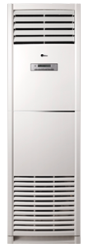

**Product Features**

* dry function
* wide voltage
* active PFC technology
* more luxury to your living room
* anti dust

**Specification**

**Type** Wall Mounted Split AC

**Cooling (Btu/h)** 35000

**Voltage (V)** 220-240

**Power Input (W)** 5800

**EER (Btu/W-h-W/W)** 5.7-2.80